Case Study: GST BILLING SYSTEM

**INTRODUCTION**

A GST BILLING System is an essential tool in a shop or a retail store in keeping track of financial data, inventories, generation of invoices & bills, as per the guidelines of **GST**. Filing of complex data becomes simpler using this system. The main objective of this project is to connect all small businesses to the billing system as per the Goods and Service Tax system.

**RESEARCH**

After visiting the owners of small shops and retail stores, I have decided to design a simple database for the shopkeepers to record their data easily. Then I will connect this database with Python interpreter for the ease of record filing and saving inventory. The other billing softwares in the market are way too expensive and this system is budget friendly and effective.

**SECURITY AND MAINTANENCE**

Security and authentication of data will be maintained. The data will be stored in SQL system, which is highly reliable and simpler to use, and the best part is that the security is managed with the help of a password.

**CONCLUSION**

The designed system is easy to allow a small business to register their details and generate bills with the help of Python.

FLOWCHART

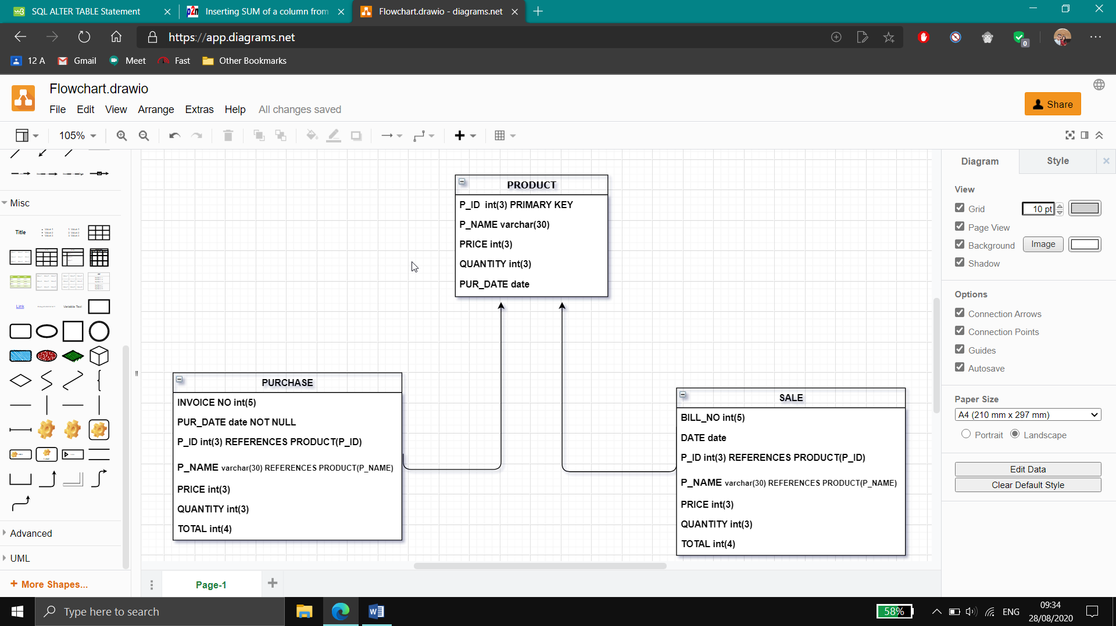

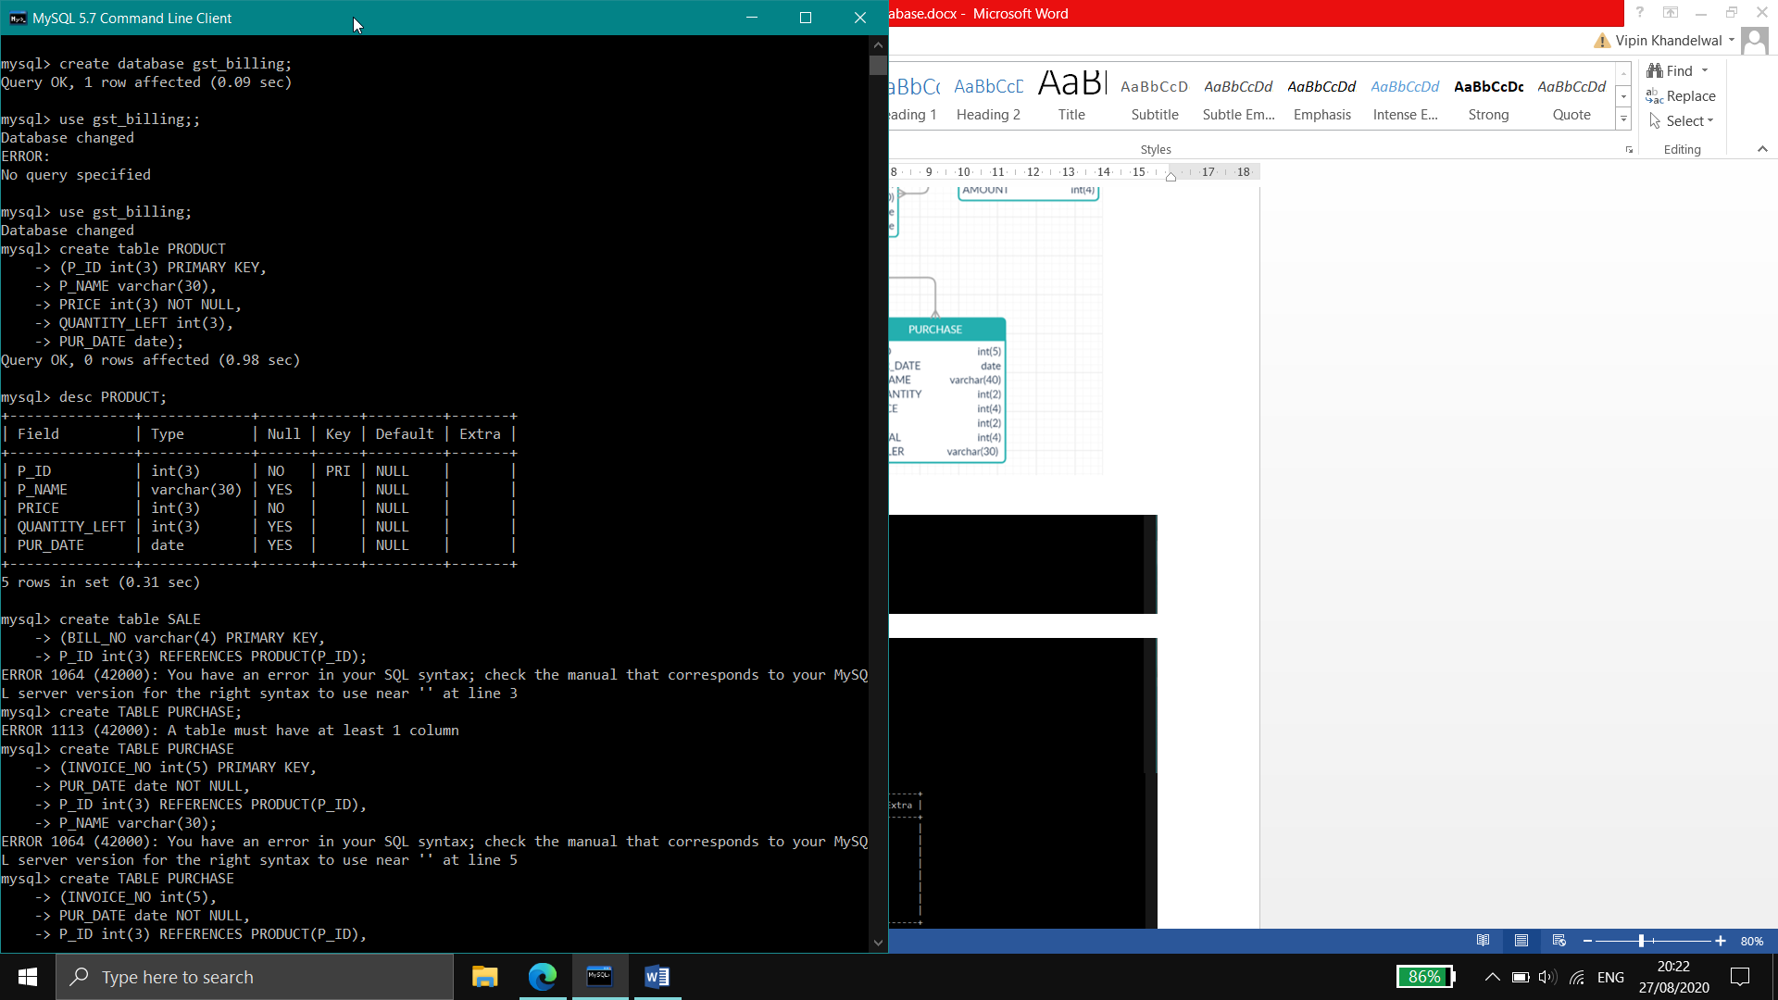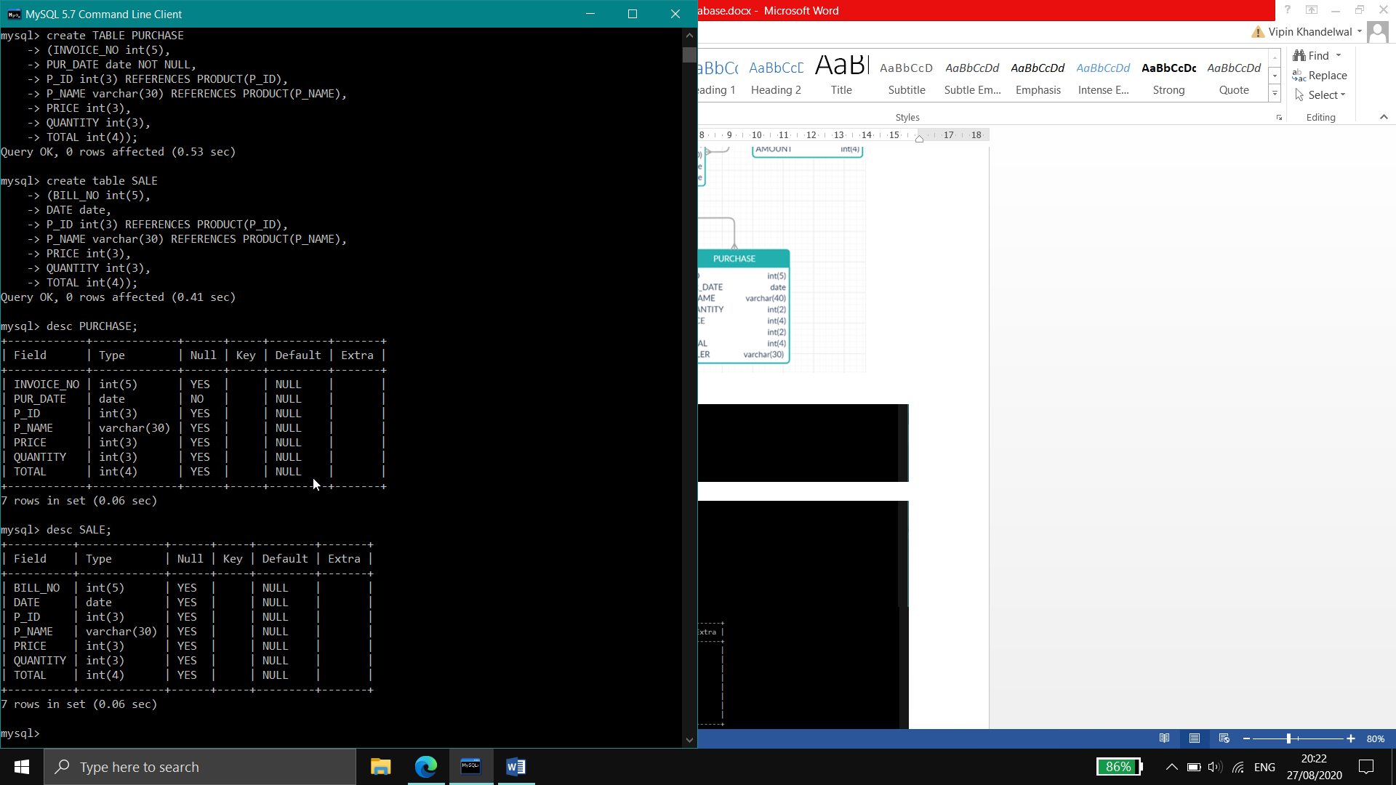

DATABASE: **GST_BILLING**

**#GST Billing Software**

**## FUNCTIONS ##**

**# VIEW #**

**def view_product():**

from tabulate import tabulate

import mysql.connector

mycon=mysql.connector.connect(

host='localhost',

user='root',

passwd='pass',

database='gst_billing',

charset='utf8')

cursor=mycon.cursor()

cursor.execute('select * from PRODUCT;')

myresult=cursor.fetchall()

print(tabulate(myresult, headers=cursor.column_names))

**def view_sale():**

from tabulate import tabulate

import mysql.connector

mycon=mysql.connector.connect(

host='localhost',

user='root',

passwd='pass',

database='gst_billing',

charset='utf8')

cursor=mycon.cursor()

cursor.execute('select * from SALE;')

myresult=cursor.fetchall()

print(tabulate(myresult, headers=cursor.column_names))

**def view_purchase():**

from tabulate import tabulate

import mysql.connector

mycon=mysql.connector.connect(

host='localhost',

user='root',

passwd='pass',

database='gst_billing',

charset='utf8')

cursor=mycon.cursor()

cursor.execute('select * from PURCHASE;')

myresult=cursor.fetchall()

print(tabulate(myresult, headers=cursor.column_names))

**# VIEW PARTICULAR PRODUCT#**

**def view_particular_product():**

from tabulate import tabulate

import mysql.connector

mycon=mysql.connector.connect(

host='localhost',

user='root',

passwd='pass',

database='gst_billing',

charset='utf8')

cursor=mycon.cursor()

a=input('Product ID of the Product:')

query="select * from PRODUCT where P_ID=('{}')".format(a)

cursor.execute(query)

myresult=cursor.fetchall()

print(tabulate(myresult, headers=cursor.column_names))

**def view_particular_sale():**

from tabulate import tabulate

import mysql.connector

mycon=mysql.connector.connect(

host='localhost',

user='root',

passwd='pass',

database='gst_billing',

charset='utf8')

cursor=mycon.cursor()

a=input('Enter Bill no. :')

b=input('Date of the sale')

query="select * from SALE where BILL_NO=('{}') and DATE=('{}')".format(a,b)

cursor.execute(query)

myresult=cursor.fetchall()

print(tabulate(myresult, headers=cursor.column_names))

**def view_particular_purchase():**

from tabulate import tabulate

import mysql.connector

mycon=mysql.connector.connect(

host='localhost',

user='root',

passwd='pass',

database='gst_billing',

charset='utf8')

cursor=mycon.cursor()

a=input('Enter Invoice no. :')

b=input('Purchase Date')

query="select * from PURCHASE where INVOICE_NO=('{}') and PUR_DATE=('{}')".format(a,b)

cursor.execute(query)

myresult=cursor.fetchall()

print(tabulate(myresult, headers=cursor.column_names))

**# INSERT #**

**def insert_product():**

import mysql.connector

mydb=mysql.connector.connect(

host='localhost',

user='root',

passwd='pass',

database='gst_billing',

charset='utf8')

mycursor=mydb.cursor()

a=input('Product ID: ')

b=input('Product Name: ')

c=input('Price: ')

d=input('Quantity Remaining: ')

e=input('Purchase Date: ')

query="insert into PRODUCT(P_ID,P_NAME,PRICE,QUANTITY_LEFT,PUR_DATE)values('{}','{}','{}','{}','{}')".format(a,b,c,d,e)

mycursor.execute(query)

mydb.commit()

print('Record Inserted Successfully')

**def insert_sale():**

import mysql.connector

mydb=mysql.connector.connect(

host='localhost',

user='root',

passwd='pass',

database='gst_billing',

charset='utf8')

mycursor=mydb.cursor()

a=input('Bill No.: ')

b=input('Sale Date: ')

c=input('Product ID: ')

d=input('Product Name: ')

e=input('Price: ')

f=input('Quantity: ')

g=input('Total: ')

query="insert into SALE(BILL_NO,DATE,P_ID,P_NAME,PRICE,QUANTITY,TOTAL)values('{}','{}','{}','{}','{}','{}','{}')".format(a,b,c,d,e,f,g)

mycursor.execute(query)

mydb.commit()

print('Record Inserted Successfully')

**def insert_purchase():**

import mysql.connector

mydb=mysql.connector.connect(

host='localhost',

user='root',

passwd='pass',

database='gst_billing',

charset='utf8')

mycursor=mydb.cursor()

a=input('Invoice No: ')

b=input('Date: ')

c=input('Product ID: ')

d=input('Product Name: ')

e=input('Price: ')

f=input('Quantity: ')

g=input('Total: ')

query="insert into PURCHASE(INVOICE_NO,PUR_DATE,P_ID,P_NAME,PRICE,QUANTITY,TOTAL)values('{}','{}','{}','{}','{}','{}','{}')".format(a,b,c,d,e,f,g)

mycursor.execute(query)

mydb.commit()

print('Record Inserted Successfully')

**# UPDATE #**

**def update_product():**

import mysql.connector

mydb=mysql.connector.connect(

host='localhost',

user='root',

passwd='pass',

database='gst_billing',

charset='utf8')

mycursor = mydb.cursor()

ch=int(input('1.Update Price 2.Update Quantity Left '))

if ch==1:

a=input('Product Name:')

b=input('Updated Price is:')

query="UPDATE PRODUCT SET PRICE=('{}')where P_NAME=('{}')".format(b,a)

mycursor.execute(query)

mydb.commit()

print("Record Udated Successfully")

elif ch==2:

a=input('Product Name::')

b=input('Updated Quantity is:')

query="UPDATE PRODUCT SET QUANTITY_LEFT=('{}')where P_NAME=('{}')".format(b,a)

mycursor.execute(query)

mydb.commit()

print("Record Updated Successfully")

else:

print('Enter a valid option!')

**def update_sale():**

import mysql.connector

mydb=mysql.connector.connect(

host='localhost',

user='root',

passwd='pass',

database='gst_billing',

charset='utf8')

mycursor = mydb.cursor()

ch=int(input('1.Update Price'))

if ch==1:

a=input('Bill No. :')

b=input('Updated Price is:')

query="UPDATE SALE SET PRICE=('{}')where BILL_NO=('{}')".format(b,a)

mycursor.execute(query)

mydb.commit()

print("Record Updated Successfully")

else:

print('Enter a valid option!')

**def update_purchase():**

import mysql.connector

mydb=mysql.connector.connect(

host='localhost',

user='root',

passwd='pass',

database='gst_billing',

charset='utf8')

mycursor = mydb.cursor()

ch=int(input('1.Update Price '))

if ch==1:

a=input('Invoice No. :')

b=input('Updated Price is:')

query="UPDATE PURCHASE SET PRICE=('{}')where INVOICE_NO=('{}')".format(b,a)

mycursor.execute(query)

mydb.commit()

print("Record Updated Successfully")

else:

print('Enter a valid option!')

**# DELETE #**

**def delete_product():**

import mysql.connector

mydb=mysql.connector.connect(

host='localhost',

user='root',

passwd='pass',

database='gst_billing',

charset='utf8')

mycursor=mydb.cursor()

a=input("Type P_ID of the product to be deleted :")

query="delete from PRODUCT where P_ID=('{}')".format(a)

mycursor.execute(query)

mydb.commit() print("Record Deleted Successfully")

**def delete_sale():**

import mysql.connector

mydb=mysql.connector.connect(

host='localhost',

user='root',

passwd='pass',

database='gst_billing',

charset='utf8')

mycursor=mydb.cursor()

a=input("Bill no of the entry to be deleted: ")

b=input("Product ID of the same: ")

query="delete from SALE where BILL_NO=('{}') and P_ID=('{}')".format(a,b)

mycursor.execute(query)

mydb.commit()

print("Record Deleted Successfully")

**def delete_purchase():**

import mysql.connector

mydb=mysql.connector.connect(

host='localhost',

user='root',

passwd='pass',

database='gst_billing',

charset='utf8')

mycursor=mydb.cursor()

a=input("Invoice no of the entry to be deleted: ")

b=input('Product ID of the same: ')

query="delete from PURCHASE where INVOICE_NO=('{}') and P_ID=('{}')".format(a,b)

mycursor.execute(query)

mydb.commit()

print("Record Deleted Successfully")

**##### MAINMENU #####**

print

**def menu():**

while(True):

print

print('Welcome!')

print('Menu')

print("- - - - - - - - - - -")

print('1. View')

print('2. Insert')

print('3. Update')

print('4. Delete')

print('5. Exit')

print("- - - - - - - - - - -")

ch=int(input( "Enter your option: "))

print

if (ch == 1) :

print

print('1. View Product')

print('2. View Sale')

print('3. View Purchase')

print

n=int(input('Choose one of the following: '))

if (n==1):

print

print('1. All Products')

print('2. Particular Product')

print

c=int(input('Choose one of the following: '))

if (c==1):

**view_product()**

elif (c==2):

**view_particular_product()**

else:

print('Enter a valid option!')

elif (n==2):

print

print('1. All Sales')

print('2. Particular Sale')

print

c=int(input('Choose one of the following: '))

if (c==1):

**view_sale()**

elif (c==2):

**view_particular_sale()**

else:

print('Enter a valid option!')

elif (n==3):

print

print('1. All Purchases')

print('2. Particular Purchase')

print

c=int(input('Choose one of the following: '))

if (c==1):

**view_purchase()**

elif (c==2):

**view_particular_purchase()**

else:

print('Enter a valid option!')

else:

print('Enter a valid option!')

break

elif ch==2:

print

print('1. Insert Product')

print('2. Insert Sale')

print('3. Insert Purchase')

print

n=input('Choose one of the following: ')

if n==1:

**insert_product()**

elif n==2:

**insert_sale()**

elif n==3:

**insert_purchase()**

else:

print('Enter a valid option!')

break

elif ch==3:

print

print('1. Update Product')

print('2. Update Sale')

print('3. Update Purchase')

print

n=input('Choose one of the following: ')

if n==1:

**update_product()**

elif n==2:

**update_sale()**

elif n==3:

**update_purchase()**

else:

print('Enter a valid option! ')

break

elif ch==4:

print

print('1. Delete Product')

print('2. Delete Sale')

print('3. Delete Purchase')

print

n=input('Choose one of the following: ')

if n==1:

**delete_product()**

elif n==2:

**delete_sale()**

elif n==3:

**delete_purchase()**

else:

break

else:

print('BYE! Program ended')

print('Thank You!')

break

**menu()**